## 2.2 Analysis Methodology

Analysis methodology is the steps taken when collecting information, analyzing information and documenting the requirements. There are several methodologies available for the analysis and development of the system like Hard approach, Soft approach, Combined approach, etc.

For my project, I have chosen the Hard approach analysis methodology as it is highly structured approach and follows a logical sequence of steps, guidelines and standard. This type of approach can be used in both the small and large projects. As my system will be simple and small it will be easy for me make the system. There are other several types of Hard approach like Structured Systems Analysis and Design Methodology (SSADM), Joint Application Design (JAD), Rapid Analysis and Design (RAD), etc. Since there are many approach to choose between the Hard approach I have gone towards the SSADM as it will be easy to measure the progress of the system.

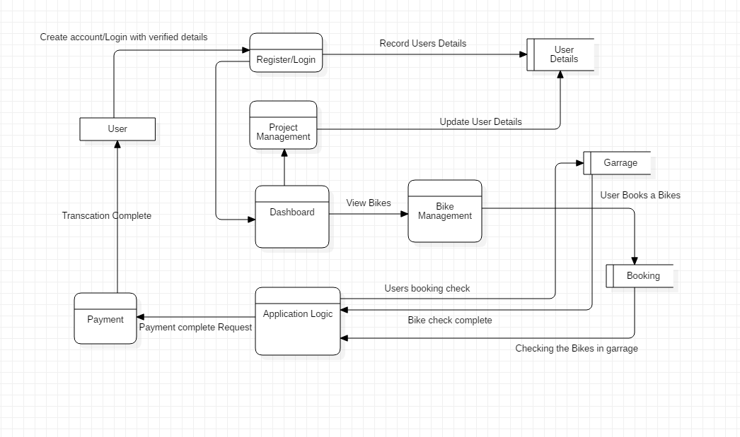

Figure 1: Data Flow Diagram for User

The following data flow diagram show how the user use the system. This DFD shows how the system process flow from one part to another with detail information on the working mechanism. This helps to get the grasp of the system process.